A paper in response to a series of questions from Peter Janis

By: Dan Fraser

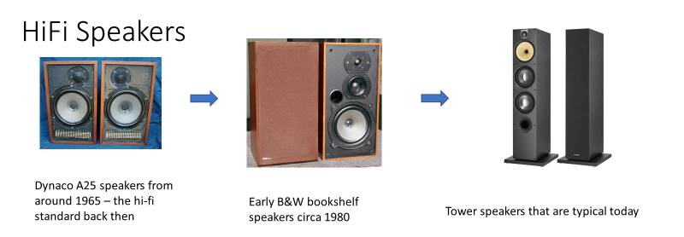

Q: How has the changes in the design of Hi-Fi Speakers changed the way we design amplifiers

When the Dynaco ST70 was developed users had large speaker cabinets with an open back. An open back removed back pressure from a speaker allowing a lot more efficiency and a peaky bass response that gave the illusion of bass but with no real oomph due to the lack of back pressure. The woofers of the day had stiff cloth surrounds which provided the required damping without any back pressure.

These speakers were very large and dominated a living room. Wives hated the size of the things. They were very efficient and needed little power. 10 Watts per channel was plenty. However they had no real deep bass but the popular music of the day did not require it. Only a few classical enthusiasts pushed the limits with very costly speakers. The majority lived with tinny sound from small speakers.

Into the early 60s popular music did not make great demands on home speakers until around 1966 where albums like Sgt. Pepper, the first popular multi-track recording, and others from many artists made demands on speakers that the classic designs could not meet. As well, people demanded smaller speaker cabinets that still had good bass.

Audio Research that came out with the first Acoustic Suspension speakers. These were amazing as they were far smaller and had very good bass. The secret was that they used a sealed box and the suspension of the woofer cone was done with a rubber foam roll. Together with the dome tweeter AR developed in 1959, the AR2 and AR3 speakers were what the world was looking for. The only catch was that with sealed boxed to use air compression to provide speaker damping, these were not very loud. They needed a lot more power to play as loud as the music of the time required and amplifiers to the hundreds of watts were eventually developed.

Dozens of other companies came out with similar products very quickly including the Dynaco A25 speakers. Some of the designs used a port on the front of the speaker to give a peak to the bass response (bass reflex).

In this time period the small power of the tube amplifiers like the Dynaco ST-70 was not sufficient and the Dynaco Company discontinued the ST-70 round 1975. Instead, making a series of Solid State amps up to 400 Watts.

In the 1980s, speaker efficiency started to rise as with the application of Theile-Small parameters and early computer aided design tools allowed the optimization of cabinets and drivers by being able to quantify more factors. The introduction of the 286 PC was instrumental in bringing this to affordability.

By the 1990s, the introduction of neodymium and cobalt magnets at popular prices was instrumental in bringing efficiency up to the point that a 35 Watt per channel amplifier was practical again. The fall of the Soviet Union was instrumental in releasing additional supplies of rare earth materials onto world markets, bringing down prices.

In researching the re-introduction of the Dynaco ST-70 in the Series 3, while some of the amplifiers designed in the 1950s, such as the Dynaco ST-70, had excellent high frequency response, when tried with modern music it was not capable of meeting the low frequency expectations of music since the late 1970s without adding a subwoofer to a system. The issue was traced to two areas. Tube amplifiers require an output transformer to drive the speaker and it was found that no existing transformer had the low frequency response to do the job. Initial efforts to improve the low end only served to make the high frequency response worse. It took well over a year of research and back and forth work with transformer makers to finally solve this issue. We now are confident that we and our Canadian transformer maker have the best transformer ever made for a tube amplifier ever in this power range.

The other component is the power supply and the ability to get a solid thud from the speakers that can be felt is that the power supply has to be able to deliver a lot of power suddenly and repeatedly up to 130 beats per minute. This requires very large filter capacitors. We are using over 10 times the size of the original amplifier’s parts to do this as well as far lower impedance wiring.

As well the big filter capacitors need to be recharged very quickly. The tube rectifier used in the original design was hopeless to deliver the current to recharge the capacitors of the day fast enough, let alone ones 10 times larger. A solid state circuit had to be developed to do this reliably. The results are impressive and in listening tests having a bottom end with modern performance together with the smooth sound of tubes while preserving the sparking top end of the original amplifier our listeners are really impressed.

Q: How has the type of music played back on speaker change the way we design amplifiers

In the 50s the technology could not record much below 50 Hertz or above 10kHz. The music from then coped with these limitations. It was not until albums like Sgt. Pepper came out and later Led Zeppelin among others that the full audio range was demanded at high sound pressure levels. By the Disco era in the late 70s, bass was expected that you could feel pounding you in the chest. As well, the high end was expected in other music styles that extended to the top range of human hearing.

By the 80s, Rap and Hip Hop along with other styles with synthetic instruments the bass was expected to be very tight all way the down to frequencies where it could only be felt.

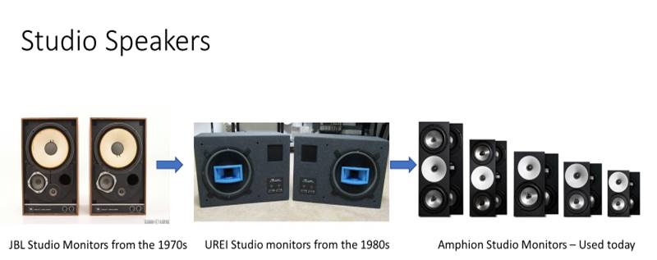

Q: How has the changes in the design of Studio Speakers changed the way we design amplifiers

Studio monitors have followed the evolution of home speakers though they tended to be slightly larger. An example of a good 60s-70s studio monitor is the JBL L100 Century

Q: How has the type of music played back on speaker change the way we design amplifiers

Same as home audio

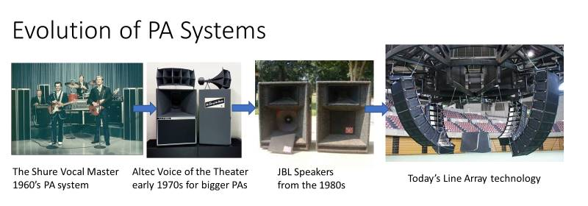

Q: How have the changes in the design of PA systems changed the way we design pre-amplifiers and other support gear

We do not make mixers for this sort of system. This includes pre-amplifiers.

The first high performance speaker to be popular was Voice of the Theater speakers like the Altec A7 date from the 1930s. They were developed for the “talkies”. Though some people still like the Altec A7, we had better stuff by the early 70s. I was using copy JBL 4560 cabinets and Martin bins from Australia though with the original drivers in the early 70s that just blew away the A7 speakers for performance.

The Shure Vocal Master was a popular medium cost system for small groups and general public address needs.

The JBL speakers shown above were just bar band gear by the 80s. Renkus-Heinz, JBL, Electrovoice and others had better stuff.

The Renkus-Heinz ST series speakers shown below represent modern speakers for medium to large venue systems when used in arrays. The passive version of these speakers was developed in the late 1980s to mid-1990s. These speakers were among the first to pay attention to the phase shift between the drivers caused by their positioning. These were computer modeled to minimize distortion from reflections between the sides of horns.

<http://www.renkus-heinz.com/st/stx-series>

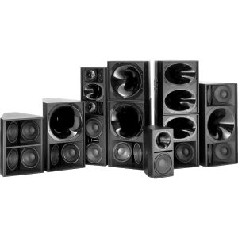

In the early 2000s, I did the amplification to make these into powered boxes. The cut away box below was my development box that sat on a cart next to my bench for over 9 years. The black “boot” in the back is a 3 channel 1700 Watt Class-D amplifier I developed with the power transformer on the bottom.

[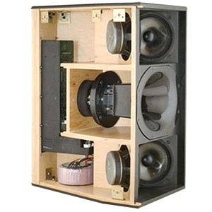](http://www.renkus-heinz.com/upload/products-st4-cutaway-2.jpg)

Line arrays became popular in the late 90s as the mathematics behind beam steering was becoming better known. Here is one I worked on. The Renkus-Heinz STLA-9. The powered version had the 1700 amplifier as seen above in each box.

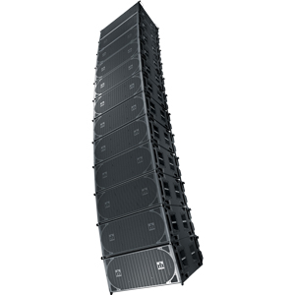

[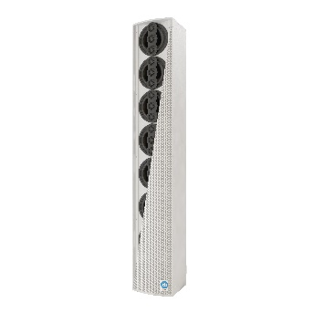](http://www.renkus-heinz.com/ic8-rn)In the early 2000s DSP technology was getting cheap enough to dedicate one to each cabinet. I was part of a pioneering team at Renkus Heinz together with a German software company to develop technology where sound could be beamed from a line array in specific directions to minimize echo and greatly improve intelligibility. [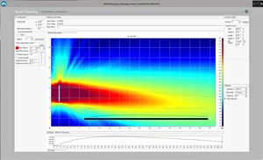](http://www.renkus-heinz.com/upload/g5bw3-1.jpg) I designed the hardware and did the design of the audio processing inside the DSP. The speaker to the right is 1 metre tall and as many as 4 were stacked in an array. Other companies are now using this technology as well. The box shown is

I developed all the steerable speaker lines. Since 2010 there has been updating only.

<http://www.renkus-heinz.com/steerable>

However all of this irrelevant for Radial as we do not make loudspeakers and none of the amplifiers we plan to make are suitable for concert or touring systems. All our work in this area is on the stage at the creation of the sound end. Our Hafler and Dynaco amplifiers are not intended for this market.

Q: How has the type of music played back on speaker change the way we design pre-amplifiers and other support gear

Same as the Hi-Fi section.

What we sell on is having features that make life less of a hassle for live music performance while preserving the original sound as much as possible and being the ultimate in reliability and durability.